**Section 2–4C: Parallel and Perpendicular Lines**

If you travel along a line that is parallel to a given line, you will stay the same distance from the given line. If you travel along a line that is perpendicular to a given line, you will travel either toward or away from the given line along the most direct path.

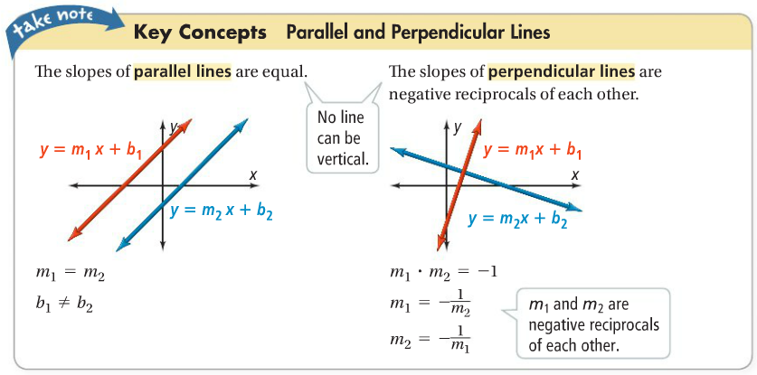

**Example 1: Writing Equations of Parallel and Perpendicular Lines**

What is the equation of each line in slope-intercept form?

1. the line parallel to $y=6x-2$ through $(1, -3)$

$m=6$ Parallel lines have the same slope.

$y-y_{1}=m(x-x_{1})$ Use point-slope form; substitute $m=6$ and $\left(x_{1}, y_{1}\right)=(1, -3)$.

$y-\left(-3\right)=6(x-1)$ Distributive Property.

$y+3=6x-6$ Write in slope-intercept form by subtracting $3$ from each side.

$y=6x-9$

1. the line perpendicular to $y=-4x+\frac{2}{3}$ through $(8, 5)$

**Question: How can you find the slope of a perpendicular line?**

Slopes of perpendicular lines are negative reciprocals, so use the equation $m_{1}=-\frac{1}{m_{2}}$.

$m=-\frac{1}{m_{2}}=-\frac{1}{-4}=\frac{1}{4}$ The slopes of perpendicular lines are negative reciprocals.

$y-y_{1}=m(x-x_{1})$ Use point-slope form; substitute $m=\frac{1}{4}$ and $\left(x_{1}, y_{1}\right)=(8, 5)$.

$y-5=\frac{1}{4}(x-8)$ Distributive Property.

$y-5=\frac{1}{4}x-2$ Write in slope-intercept form by adding 5 from each side.

$y=\frac{1}{4}x+3$